Front-End UI/UX Mini Project   
   
 Course: UI/UX Design Fundamentals

Project Title

My Favourtie City Blog

**Submitted by:**

* Aditya Mishra: (2462307) [-aditya.mishra@btech.christuniversity.in](mailto:-aditya.mishra@btech.christuniversity.in)
* Pallvi Gupta (2462346) [pallavi.gupta@btech.christuniveristy.in](mailto:pallavi.gupta@btech.christuniveristy.in)
* Vidhika Singh (2462371)

[Vidhika.singh@btech.christuniversity.in](mailto:Vidhika.singh@btech.christuniversity.in)

**Instructor Name:** Ms Nagaveena**Date of Submission**:13/08/2025 

**Institution:** Christ University ,Bangalore

**1.Abstract:**

The city blog is a creative HTML project that highlights a city I love through text, images, and links. It uses HTML elements like , , Error! Filename not specified., and to present content in a readable and engaging format. CSS was used to style the layout and enhance visual appeal.

**2.Objectives:**

* Create a personal blog webpage highlighting my favorite city using html
* Use semantic HTML tags like header ,footer ,article , and section for clear structure
* Include images, headings, and paragraphs to make the content visually engaging
* Add hyperlinks to relevant resources or attractions in the city
* Organize content for easy readability and smooth navigation
* Demonstrate foundational web development skills through layout and formatting

**3. Scope of the project:**

* Showcase a city of personal interest through a static HTML webpage
* Focus on clear content organization using semantic HTML elements
* Include sections like introduction, attractions, culture, food, and travel tips
* Embed relevant images to visually represent the city
* Provide external links to official tourism sites or related articles
* Ensure the page is readable, responsive, and easy to navigate
* Lay the foundation for future enhancements using CSS and JavaScript

**4. HTML structure Overview:**

* Html : Root element containing the entire webpage
* Head : Includes metadata, page title, and links to stylesheets
* Body : Main content area of the blog
* Header : Title of the blog and city name
* Nav : Navigation menu with anchor links to different sections
* Section : Major content blocks like "About the City", "Top Attractions", "Local Cuisine", etc.
* Article : Individual write-ups or highlights within each section
* Img :Images representing landmarks, food, or cultural elements
* A : Hyperlinks to external resources or internal na
* vigation
* Footer : Closing notes, contact info, or credits

**5. Tools & Technologies Used** :

|  |  |
| --- | --- |
| **Tool/Technology** | **Purpose** |
| **HTML5** | Markup and content structure |
| **CSS3** | Styling and layout management |
| **VS Code** | Code editor |
| **Chrome DevTools** | Testing and debugging |

**6. HTML Structure Overview**

* Used semantic tags: <header>, <nav>, <main>, <section>, <footer>
* Structured into reusable sections: About, Projects, Contact

**7. CSS Styling Strategy:**

* Section spacing: padding and margin to separate content.
* Headings: Larger font-size and distinct color for each section title.
* Box styling: Use border, box-shadow, or background-color to highlight articles or tips.
* Responsive sizing: width: 100% or max-width: 600px to fit nicely.
* Rounded corners: border-radius for a softer look.
* Shadow: box-shadow to make images stand out.
* Bullet styling: Customize list-style-type (e.g., circle, square).
* Spacing: Add margin-bottom between list items.

8. **challenges and solutions:**

| Challenge | Solution |
| --- | --- |
| Structuring content clearly | Used semantic tags like and for organization |
| Making the page visually appealing | Applied CSS for layout, colors, and typography |
| Image alignment and sizing | Used max-width, margin, and display properties in CSS |

**9. Outcome:**

* Structured Content: Clear sections like About, Attractions, Food, and Travel Tips make it easy to navigate.
* Visual Appeal: Images and styling bring the city to life.
* User-Friendly Navigation: Visitors can jump to sections using the nav bar.
* Personal Touch: Your voice and preferences shine through in descriptions and choices.
* Responsive Layout *(if styled well)*: It looks good on both desktop and mobile.

**9.Future Enhancements:**

* Responsive Design  
  Make the blog look great on mobile and tablet screens using media queries.
* Image Gallery or Slideshow  
  Add a carousel to showcase multiple city photos interactively.
* Embedded Google Map  
  Show key locations like attractions or food spots directly on the page.

**10. Sample Code:**

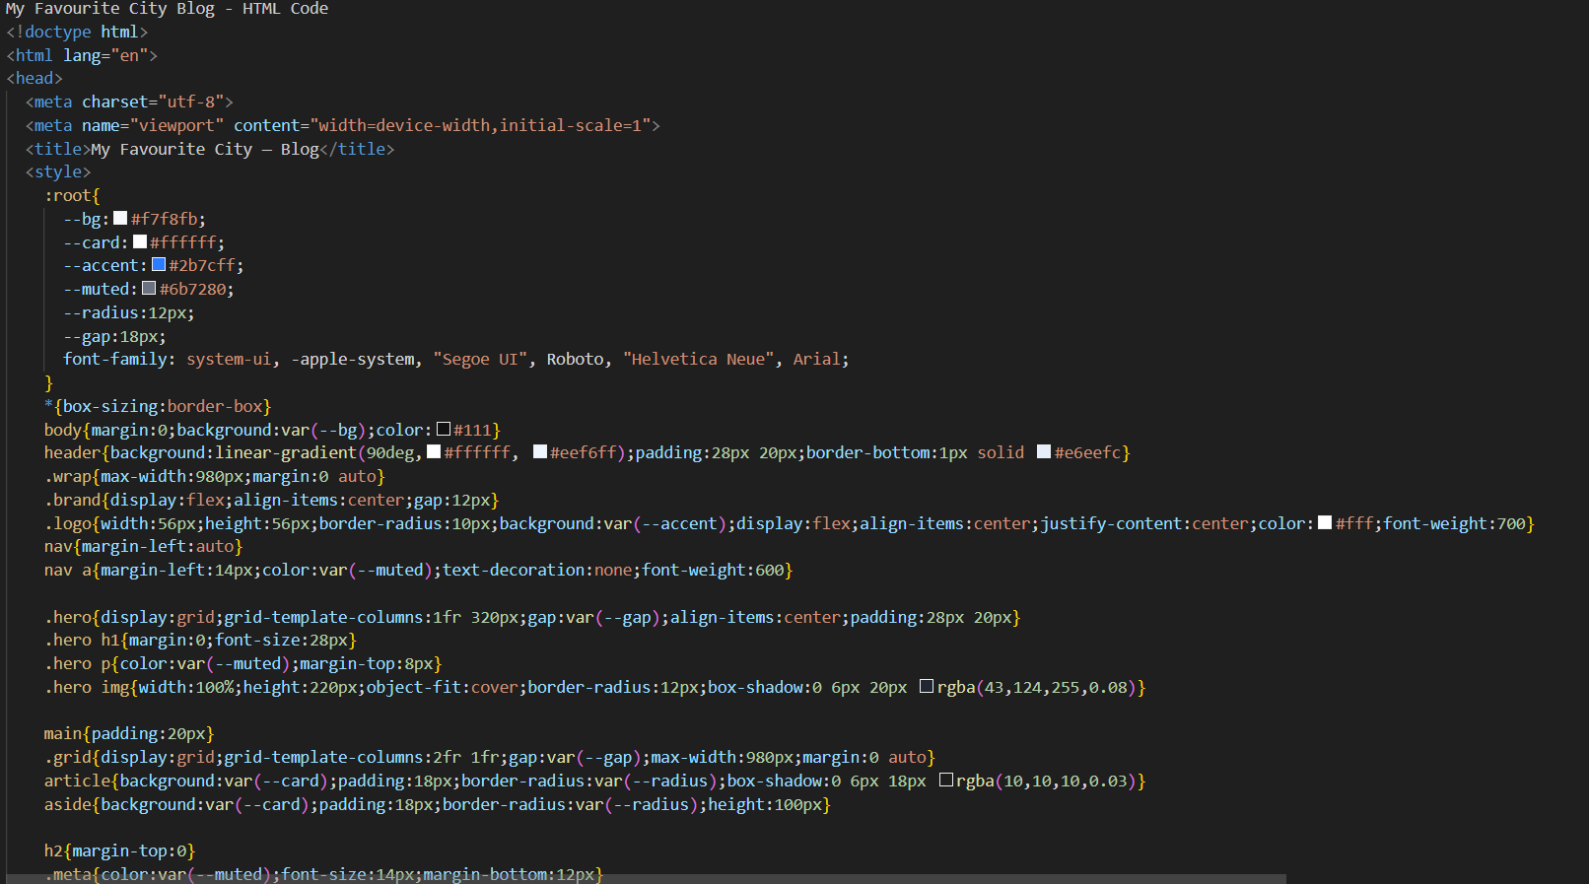

**13. Screenshots of Final Output :**

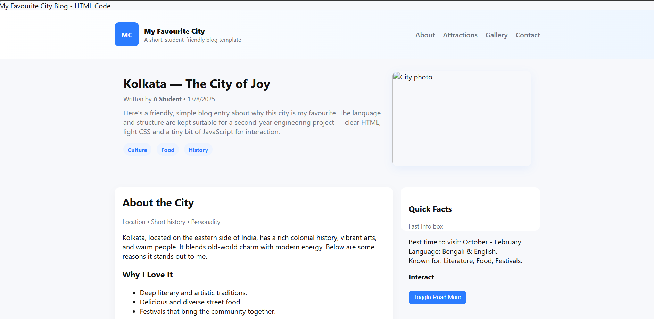

**14. Conclusion:**

Creating this blog about my favourite city helped me practice HTML structure, apply CSS styling, and organize content in a meaningful way. I enjoyed combining creativity with coding and look forward to adding more features as I continue learning.

**15.Reference:**

L&T LMS : https://learn.lntedutech.com/Landing/MyCourse